
Report

Team ID | MCA
Project Name | Online Learning Engagement and Student Performance Analysis
Maximum Marks | 5 Marks

A report is a comprehensive document that provides a detailed and structured account of data analysis, findings, and insights. It is typically used for in-depth analysis, documentation, and communication of results. Reports are suitable for a diverse audience, including decision-makers, analysts, and stakeholders who need a comprehensive understanding of the data.
Designing a report in Power BI involves connecting to data sources, creating visualizations like charts and graphs, customizing their appearance and interactivity, organizing them logically on the canvas, formatting elements for consistency and clarity, and optionally creating dashboards for a summarized view. Throughout the process, it's essential to consider the audience's needs and ensure the report effectively communicates insights from the data. Finally, iterate based on feedback to continually improve the report's design and usefulness.

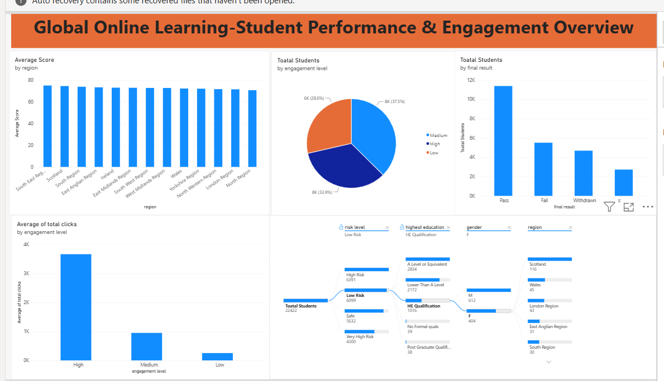
Observations Drawn from the Power BI Dashboard
1. Student Performance Analysis
- The dashboard shows an overall average score of 72.8.
- Average scores across regions remain relatively close, generally around 70–75, indicating fairly consistent performance.
2. Student Engagement Analysis
- Students are distributed across Medium (37.5%), High (33.9%), and Low (28.6%) engagement levels.
- High-engagement students have the highest average activity, with approximately 3.7K average clicks.
3. Final Result Analysis
- Pass is the largest final-result category, with approximately 11.4K students.
- This is followed by around 5.5K Fail and 4.7K Withdrawn students, showing differences in student outcomes.
4. Student Risk Analysis
- The dashboard categorizes students into High Risk, Low Risk, Safe, and Very High Risk groups.
- This classification can help identify students who may require additional academic support and monitoring.

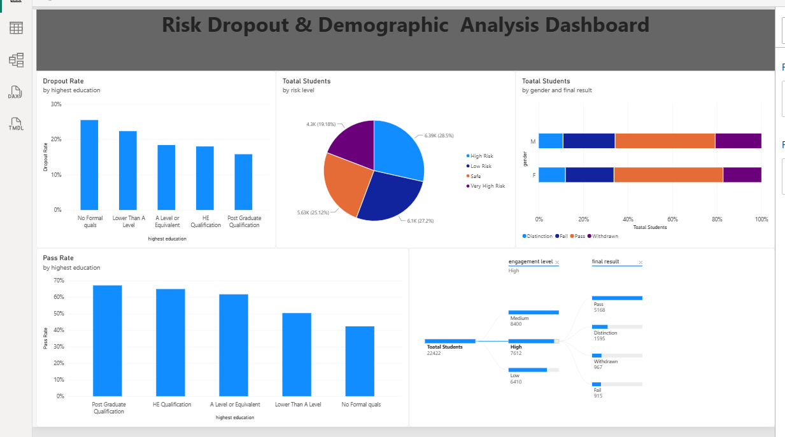
Observations Drawn from the Risk, Dropout & Demographic Analysis Dashboard
Here are the key observations from this dashboard:
1. Dropout Rate Analysis:
● The highest dropout rate is among students with No Formal Qualifications (around 25%).
● The dropout rate decreases as the education level increases, with Post Graduate Qualification showing around 16%.
2. Student Risk Analysis:
● Students are distributed across High Risk (28.5%), Low Risk (27.2%), Safe (25.1%), and Very High Risk (19.2%) categories.
● This indicates that a significant proportion of students fall into the different risk categories and may require monitoring.
3. Pass Rate Analysis:
● Students with Post Graduate Qualification have the highest pass rate (around 67%).
● The pass rate gradually decreases across lower education levels, reaching approximately 42% for students with No Formal Qualifications.
4. Gender and Final Result:
● The stacked bar chart compares Distinction, Fail, Pass, and Withdrawn results for male and female students.
● Pass represents the largest portion for both genders, while Distinction, Fail, and Withdrawn make up the remaining outcomes.

